**Mobile Games – Demographics**

We are planning to target our game at the mobile gaming audience and specifically females aged 25+.

**Male vs Female**

|  |  |  |
| --- | --- | --- |
| **Measure** | **Male** | **Female** |
| Percentage split by gender | 37 | **63** |
| Percentage who play daily | 47 | **60** |
| Percentage who spend $$$ in the games | 31 | **36** |

**Game time played**

Women on average play 25% longer than Men per game.

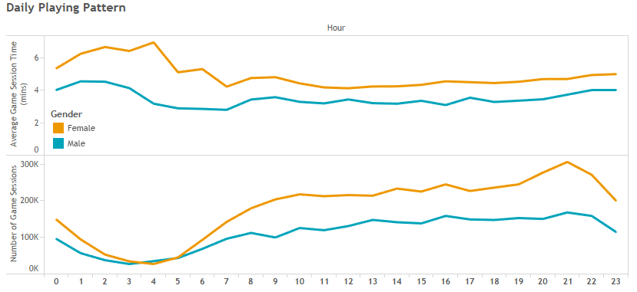

**Time spent on Mobile Games in the US**

* 23 minutes per day
* 2.7 hours per week
* 5.8 days per year
* 1.3 years per lifetime

**Age distribution**

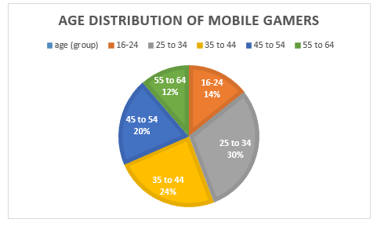

**Age / Spend**

All the sources seem to agree about one thing, the older the gamer the more likely they are to spend money on virtual items within the game.

The age breakdown of mobile virtual goods buyers is below:

* 18-25: 10% of all gamers bought virtual goods
* 25-35: 22% of all gamers bought virtual goods
* 35-45: 50% of all gamers bought virtual goods
* 45+: 70% of all gamers bought virtual goods

**Most popular games**

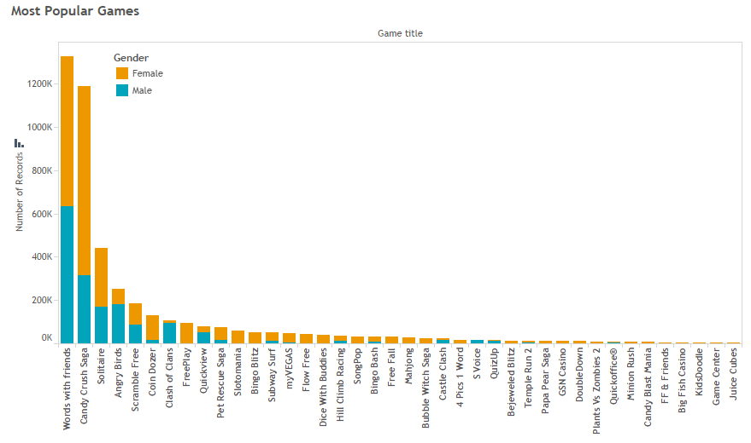

**References:**

<https://www.androidheadlines.com/2018/03/mobile-game-study-reveals-interesting-demographics.html>

<https://www.mmaglobal.com/research/myth-busting-mobile-gaming-demographics>

<https://gameanalytics.com/blog/mobile-consumers-women-2018.html>

<https://www.forbes.com/sites/johngaudiosi/2011/12/20/new-report-details-demographics-of-mobile-gamers-buying-virtual-goods/#4638ee783739>